# How to make a Wall go Up with a Trigger:

Pre-preparing: I am assuming you know where Hierarchy and Inspector are, and already have a model set. As per my previous tutorials, ‘[ASB]’ means “As Shown Bellow”. And please, remember to save your work as often as you can. Note Comments in C# start with // and are green in this tutorial

**Step 1**: Open **Unity** and load the **scene** you would like to set up the trigger and the wall, I am assuming (based on my previous tutorials) you are using FP and already have a Wall, Character and Floor. [ASB]

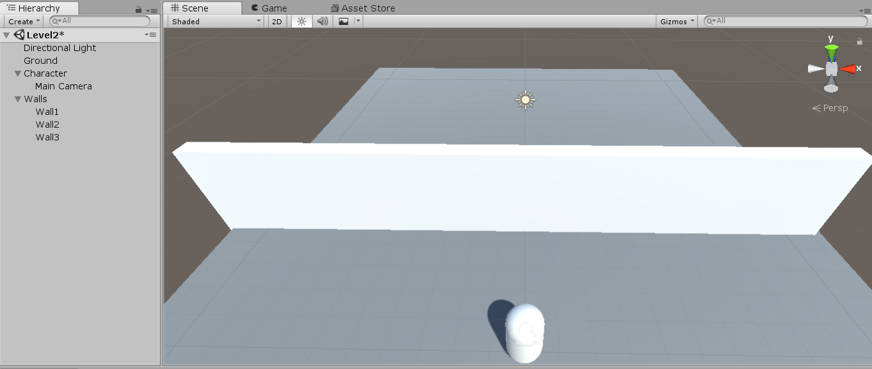

To make your life easier: **Create Empty** and call it Triggers, and to make my life easier, I have changed the **colour** of the Walls.

**Step 2**: **Right Click** on **Triggers** > **3D Object** > **Cube**, Rename the cube to TriggerOpen and change its size so it would cover the front of your door [ASB]

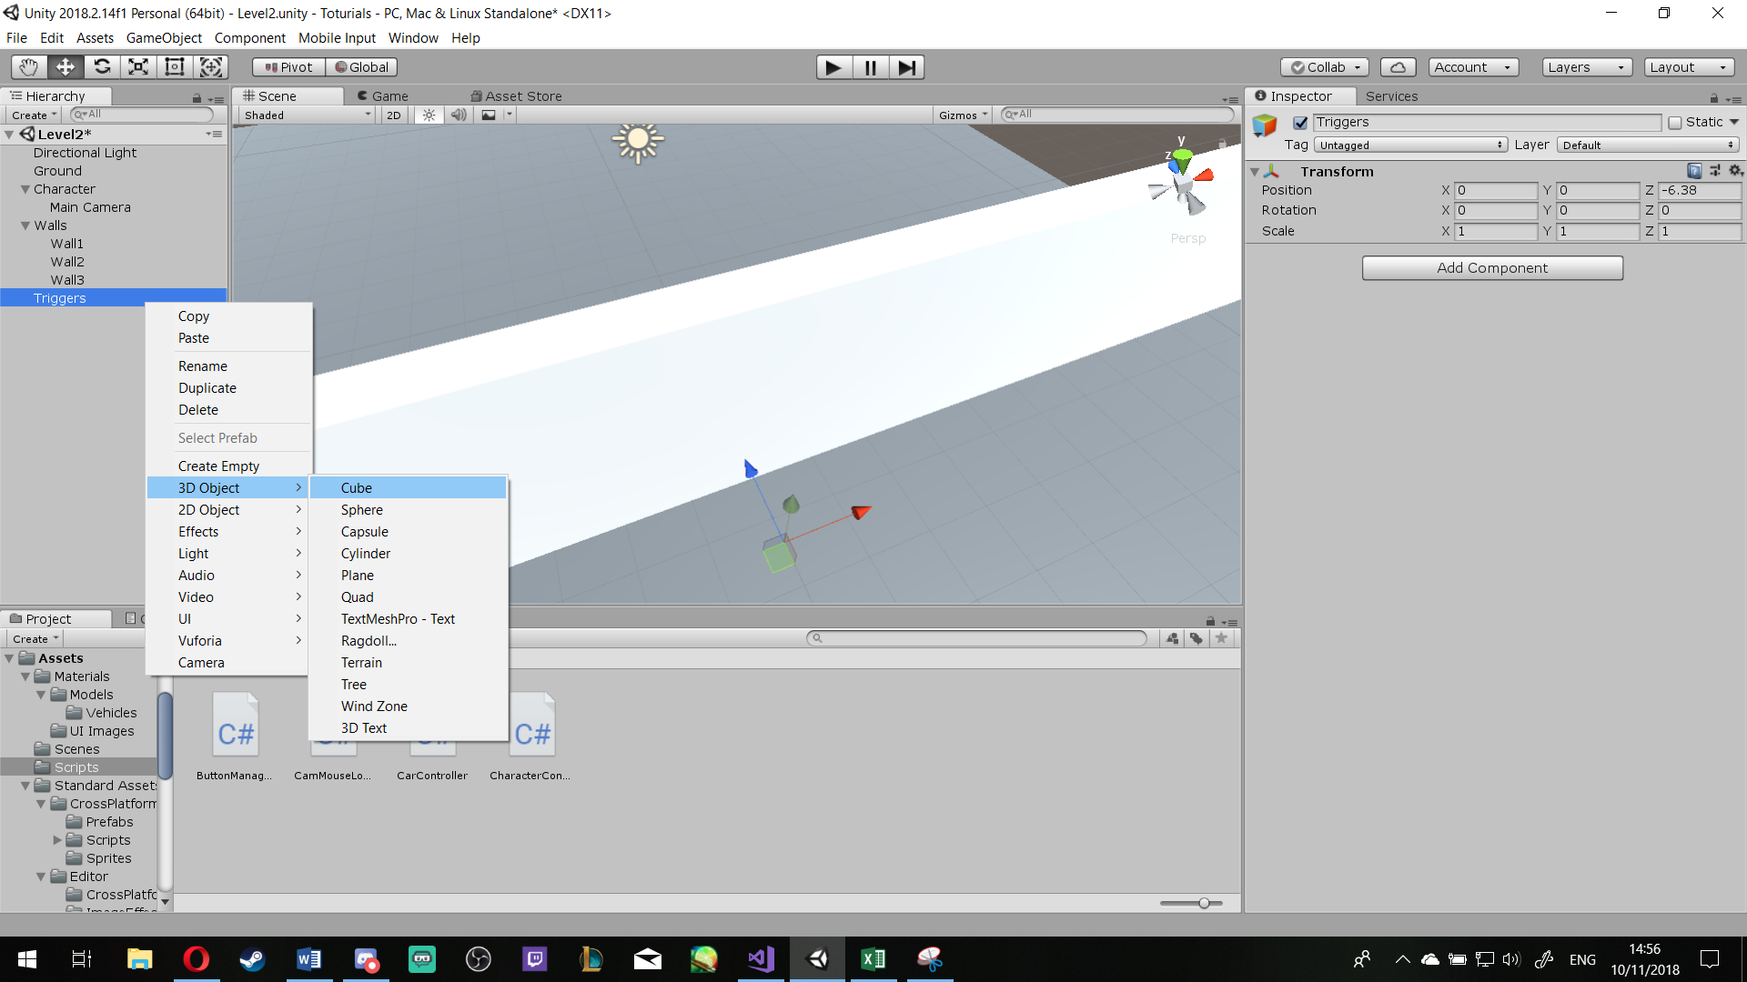

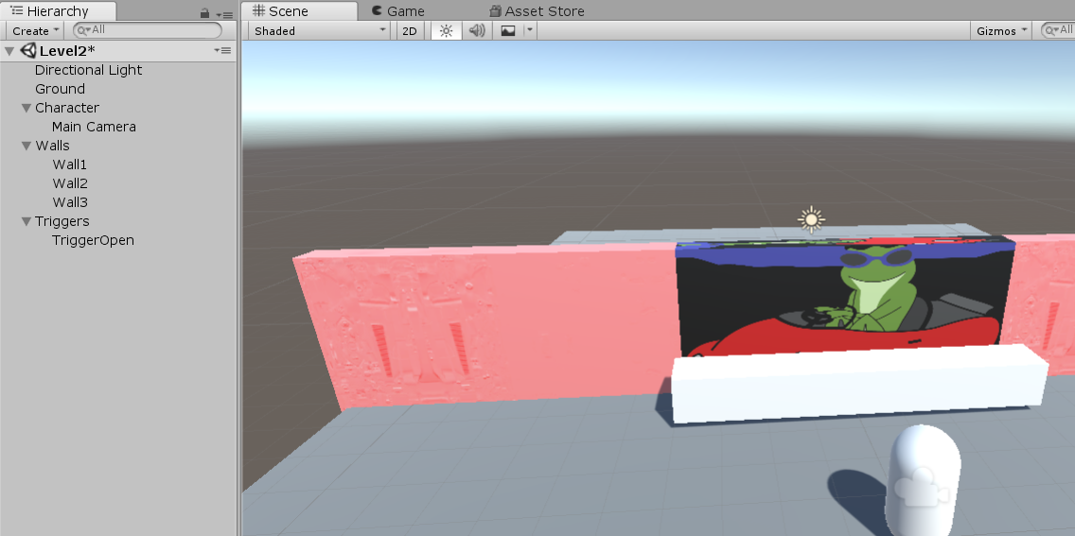

**Step 3**: Click on the TriggerOpen, in **Inspector** > **Add Component** > **WallUp** > **NewScript** > **Add**

Then right click on the **script** > **Edit Script** [ASB]

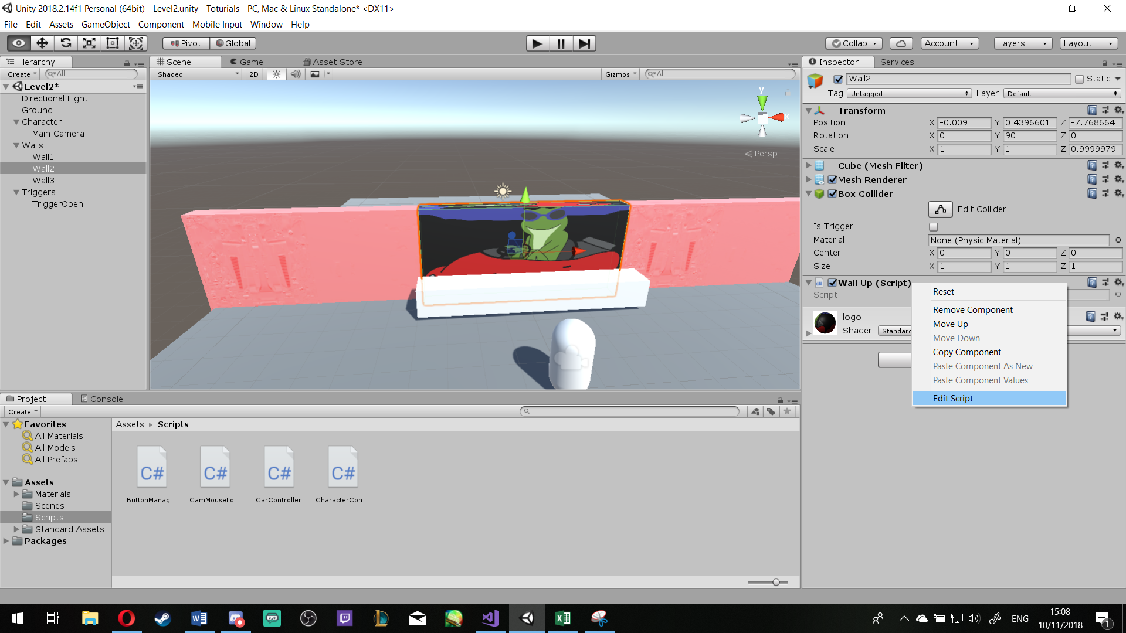

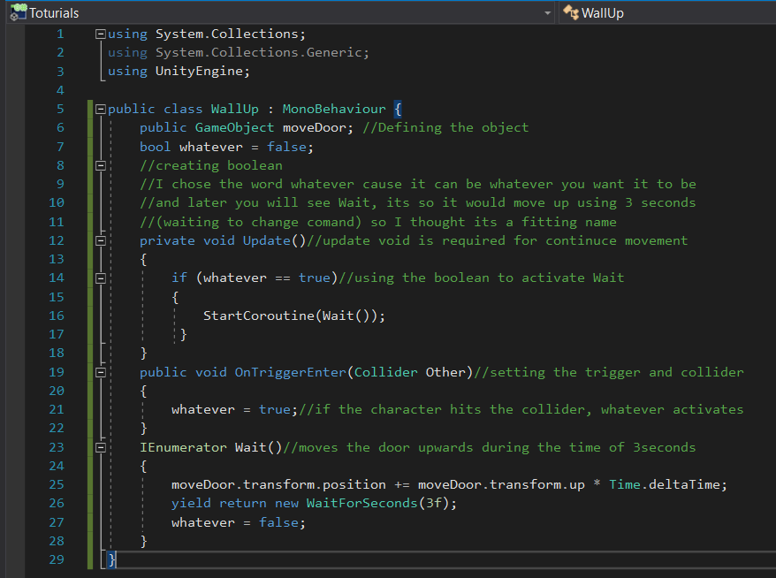**Step 4**: Use the Code bellow:

**Step 5**: Save and Return to **Unity**, now in the Inspector, a new section is available under Script [ASB]

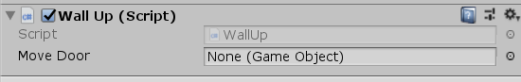

Go to the Hierarchy, **Drag** and **Drop** the **Wall** you want it to move up, onto the “**Move Door**” or click the little circle and find the Wall you want and add it in. [ASB]

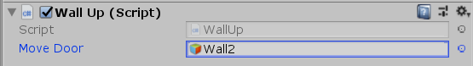

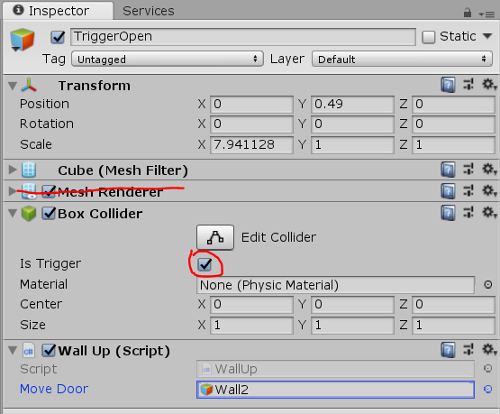Then make sure, under the **Box Collider**, the **Trigger** is Ticked and feel free to **delete** its Mesh Renderer

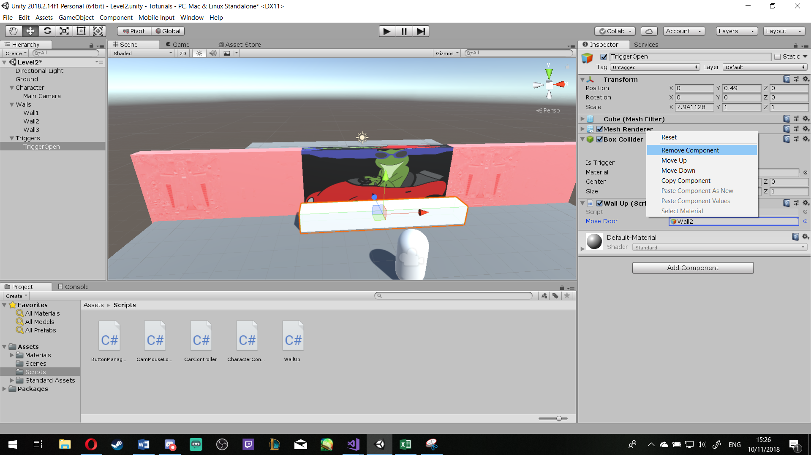

**Step 6**: Right Click on **Triggers** > **3D Object** > **Cube** and **rename** it to TriggerClose

Resize and position it behind the wall that will open [ASB]

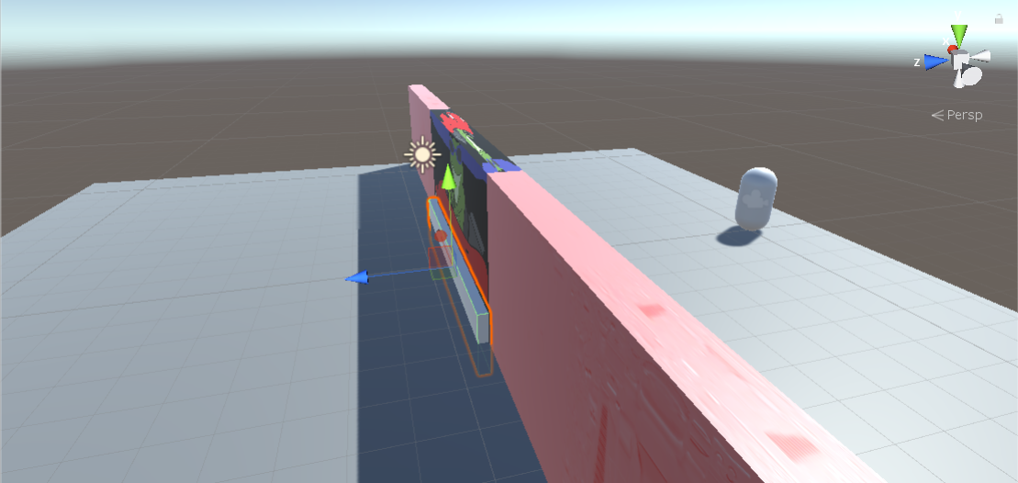

**Step 7**: Go to its **Inspector** > **Add Component** > **WallDown** > **New Script** > **Add**

Right click on the script and **Edit Script**, as shown in ***Step 3***.

Write the same code as ***Step 4*** **BUT** change the following code from

moveDoor.transform.position += moveDoor.transform.up * Time.deltaTime;

**To this**: //(adding the *-1*) makes it go other way

moveDoor.transform.position += moveDoor.transform.up * -1 * Time.deltaTime;

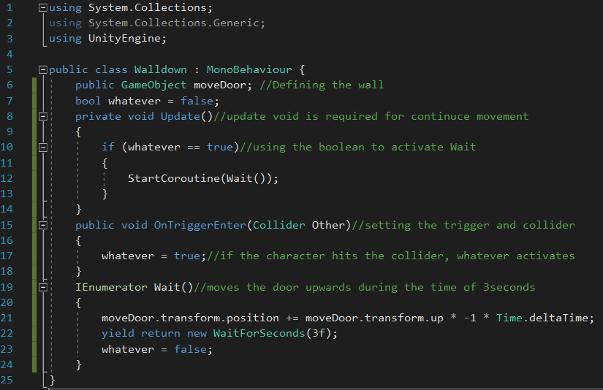as shown below:

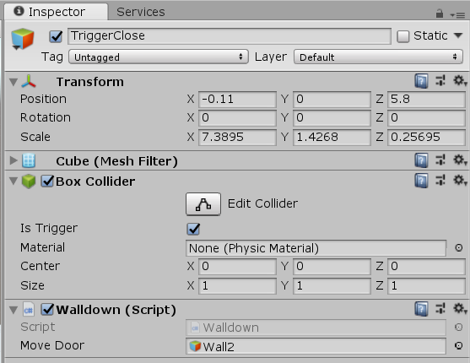**Step 8**: Repeat ***Step 5*** but with TriggerClose [ASB]

**Step 9**: Save and Enjoy